Building Product Detail Page

The process of building the Product Detail page is similar to the steps used for the Product Listing page. We start by defining the expected page layout. The page should display essential product information, including:
- Page Title
- Product Name
- Product Image
- Product Price
For clarity, a visual layout example is provided below.
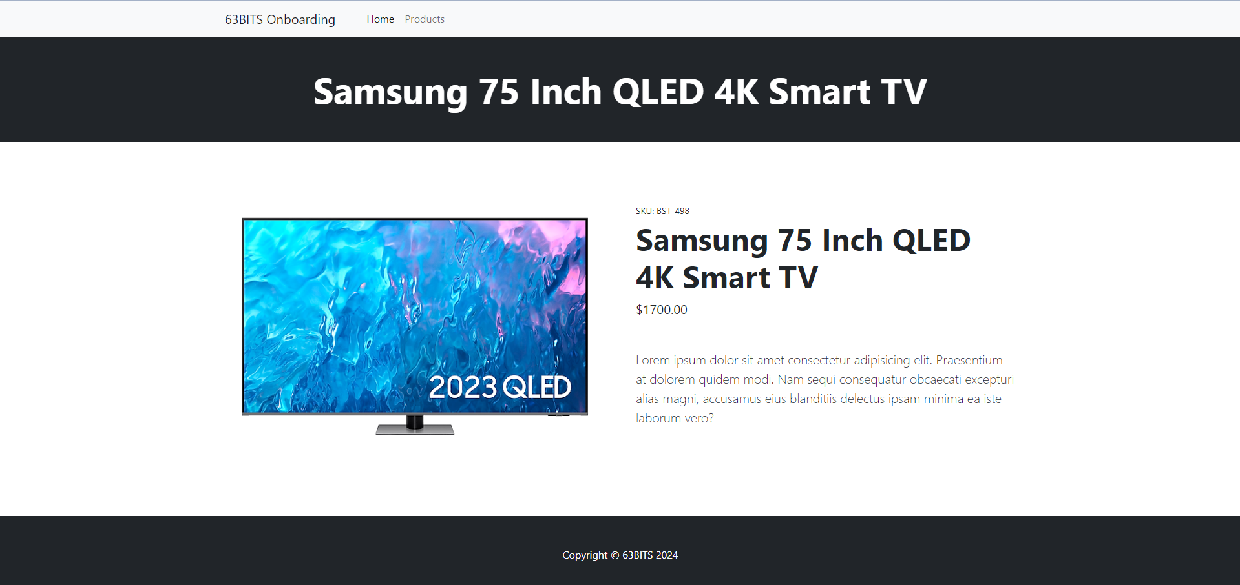

Note: The visual includes additional fields, such as SKU and Product Description. These can be ignored for now.

Model
Navigate to SixtyThreeBits.Web → Models → Website → Products and create ProductWebsiteModel.cs
The class name ProductWebsiteModel uses the singular form because this model handles a single product, unlike ProductsWebsiteModel which handles multiple products.

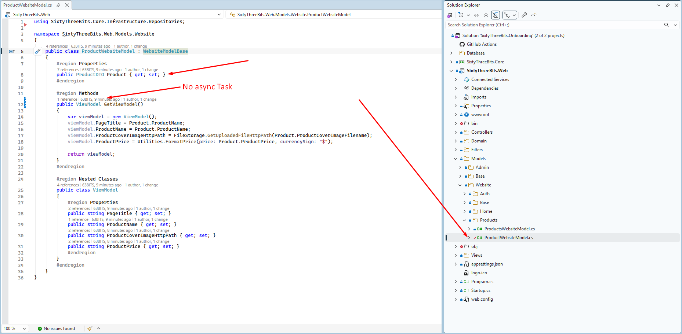

As you can notice, this model has ProductDTO Product property. You may wonder, where is the database call retrieving the product from the database by its ID? This is exactly what comes next.

Controller
Before creating the controller navigate to SixtyThreeBits.Web → Domain → Utilities and open RouteKeys63.cs
RouteKeys63 is a static class, containing only const string properties, that represent key parameters used in routing throughout the application.

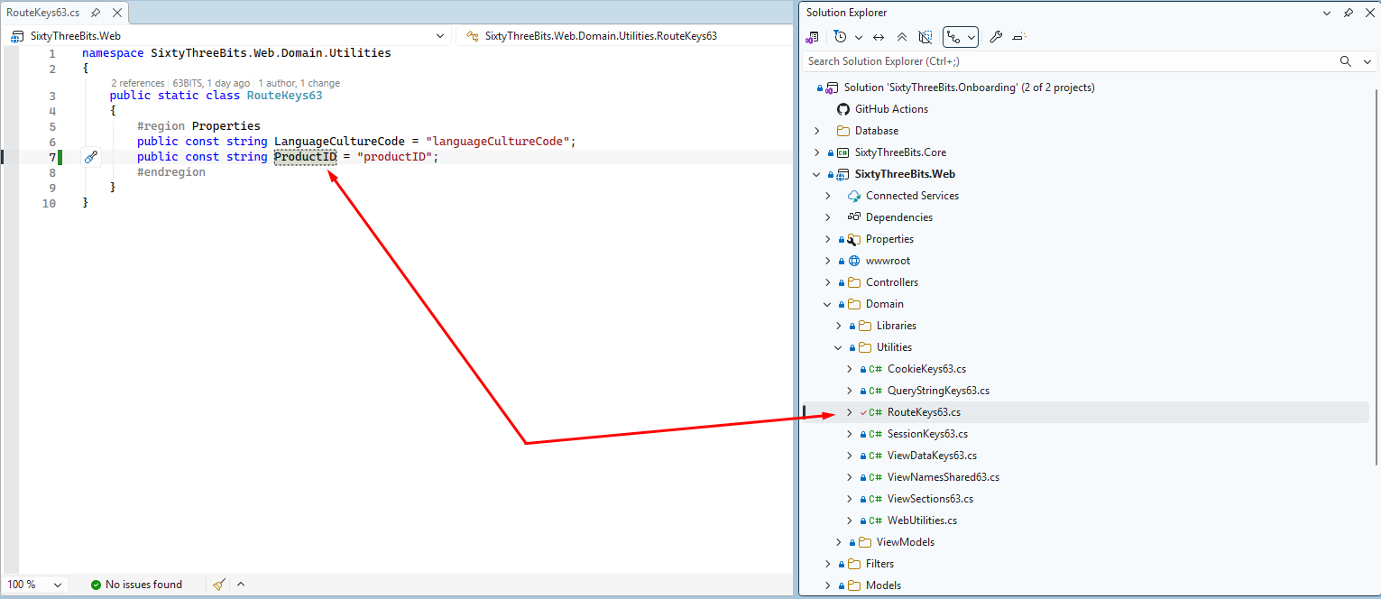

Now navigate to SixtyThreeBits.Web → Controllers → Website → Products and create ProductWebsiteController.cs
The class name ProductWebsiteController uses the singular form because this controller handles a single product, unlike ProductsWebsiteController which handles multiple products.

Create controller class, according to screenshot below:
- Register _viewName
- Create empty action Product()
- Add route, that uses our newly created RouteKeys63.ProductID to capture ID of the product from the route.
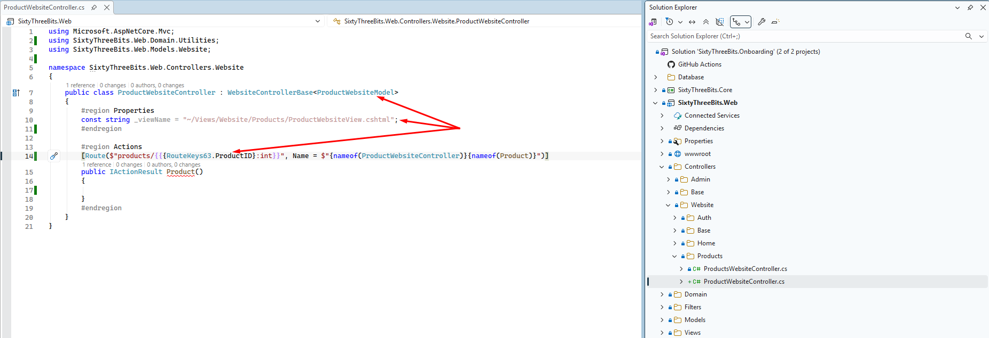

As RouteKeys63.ProductID is registered as const, following expression:
$"product/{{{RouteKeys63.ProductID}:int}}", is translated into the: "product/{productID:int}" string at the compile time. This translation represents regular route string, that will capture ID of the product via productID route key.
The reason for using RouteKeys63.ProductID is to avoid parameter hard coding in routing.

Action Filter
Now we need to capture the value of ProductID from the route and retrieve product, by it’s ID from the database. This is where we need to use controller level action filter.
The goal of action filter is to execute the block of code, before process will reach action method call.
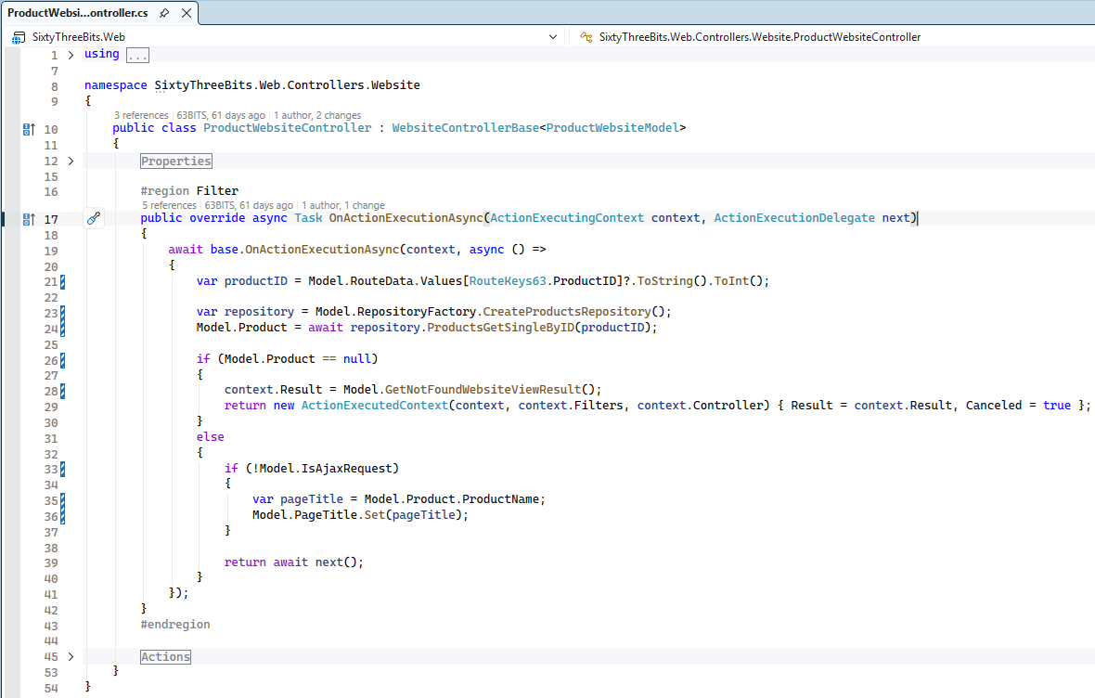

OnActionExecutionAsync is the built-in method provided by MVC Controller. It can be overriden to execute custom block of code, before Action method is executed.

We begin with await base.OnActionExecutionAsync(...),this expression executes OnActionExecutionAsync but for WebsiteControllerBase class. Base class has it’s own logic which must be executed before process reach our code.

Next we extract the ID of the product from the url
var productID = model.RouteData.Values[RouteKeys63.ProductID]?.ToString().ToInt();

This is where we use our previously registered RouteKeys63.ProductID and avoid hardcoding.

Next we call repository method to retrieve product by it’s ID
var repository = model.RepositoryFactory.CreateProductsRepository();
model.Product = await repository.ProductsGetSingleByID(productID);

Finally, we make a check:
if we were able to retrieve product by it’s ID:
- We set product name, as browser tab title
var pageTitle = model.Product.ProductName;
model.PageTitle.Set(pageTitle);
- We pass process to action method
return await next();

if product does not exists:
- We set our custom build Not Found Result
context.Result = model.GetNotFoundWebsiteViewResult();
- We return our custom build Not Found Result
return new ActionExecutedContext(...)
- Process will not continue to action method.

Action Method
Implement action method according to screenshot below.
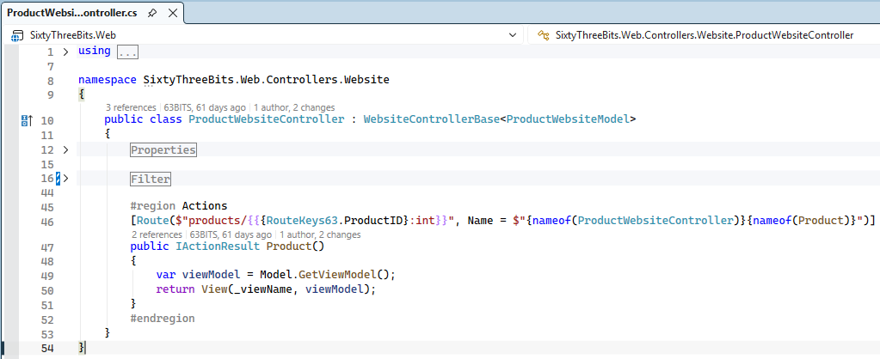

View
Navigate to SixtyThreeBits.Web → Views → Website → Products and create ProductWebsiteView.cshtml

Connect model to your view according to instructions below.
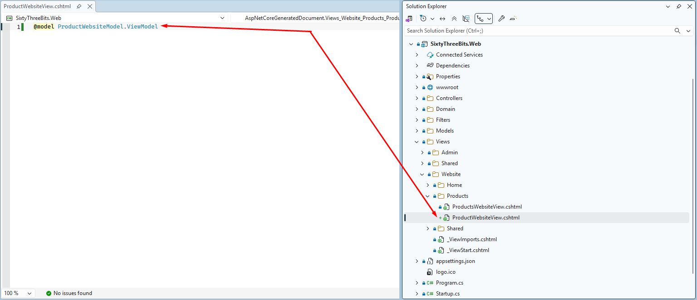

Navigate to SixtyThreeBits.Web → wwwroot → html → product.html
product.html is static HTML file which we will use for building dynamic cshtml view.

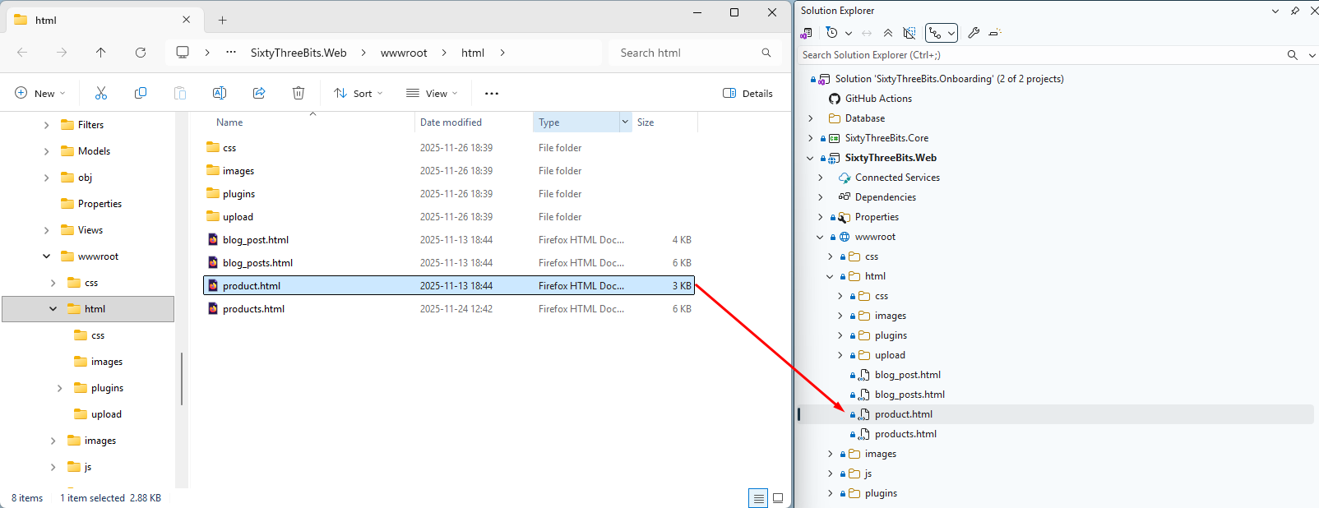

Open products.html using your web browser. This is how your final result must look.
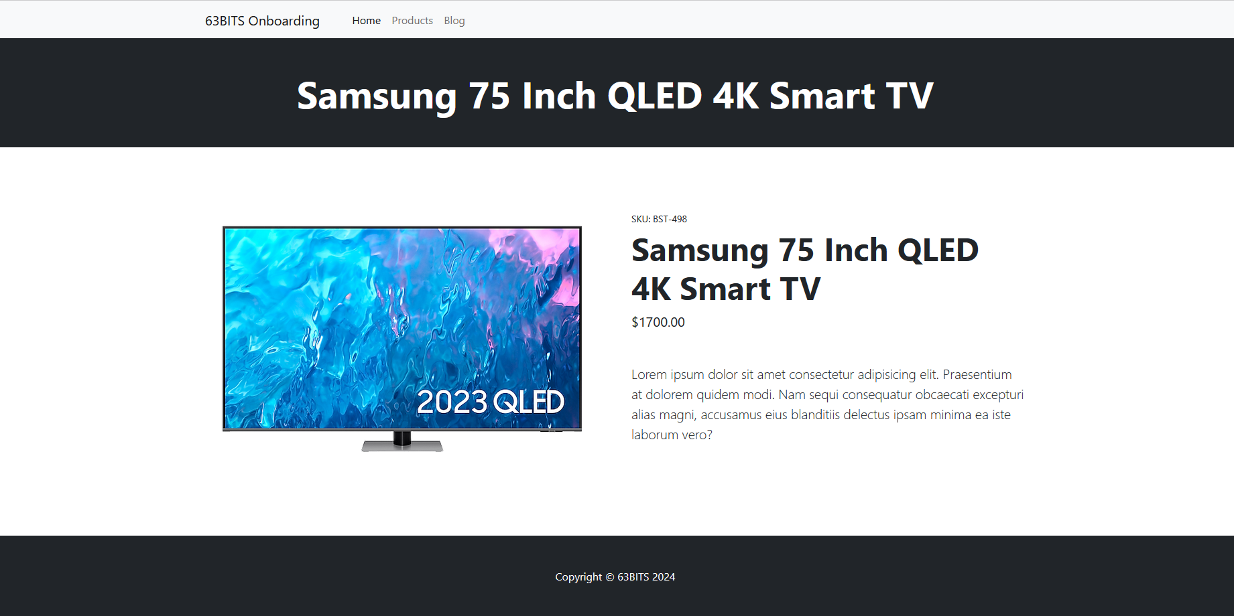

Navigate to SixtyThreeBits.Web → wwwroot → html and open product.html and copy static HTML

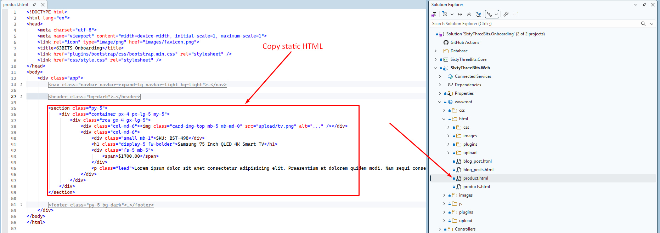

Paste it into your view and replace static content with viewModel properties.
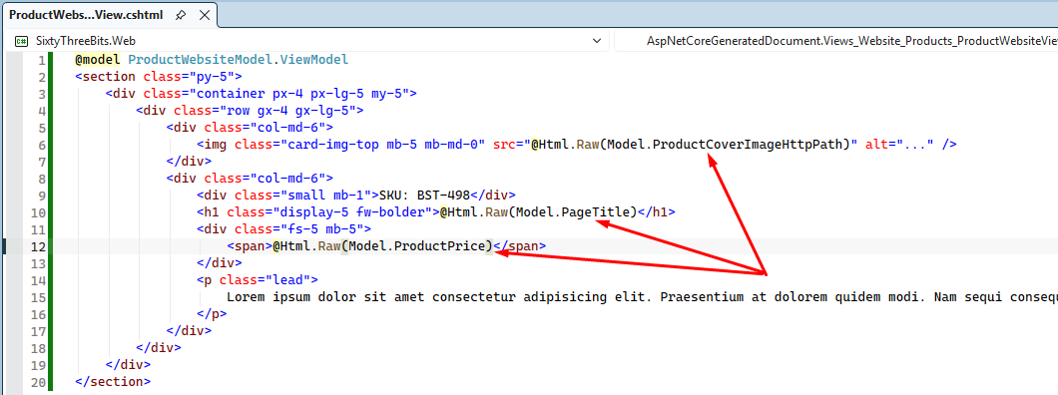

Launch

To run the project, press CTRL + F5. The browser will open and the home page will load automatically.

To view the Product Detail page, enter /products/1 in the browser’s address bar.

In this example, a product with ID 1 exists in the database. In your environment, the ID may differ, so substitute the appropriate ProductID in the URL.

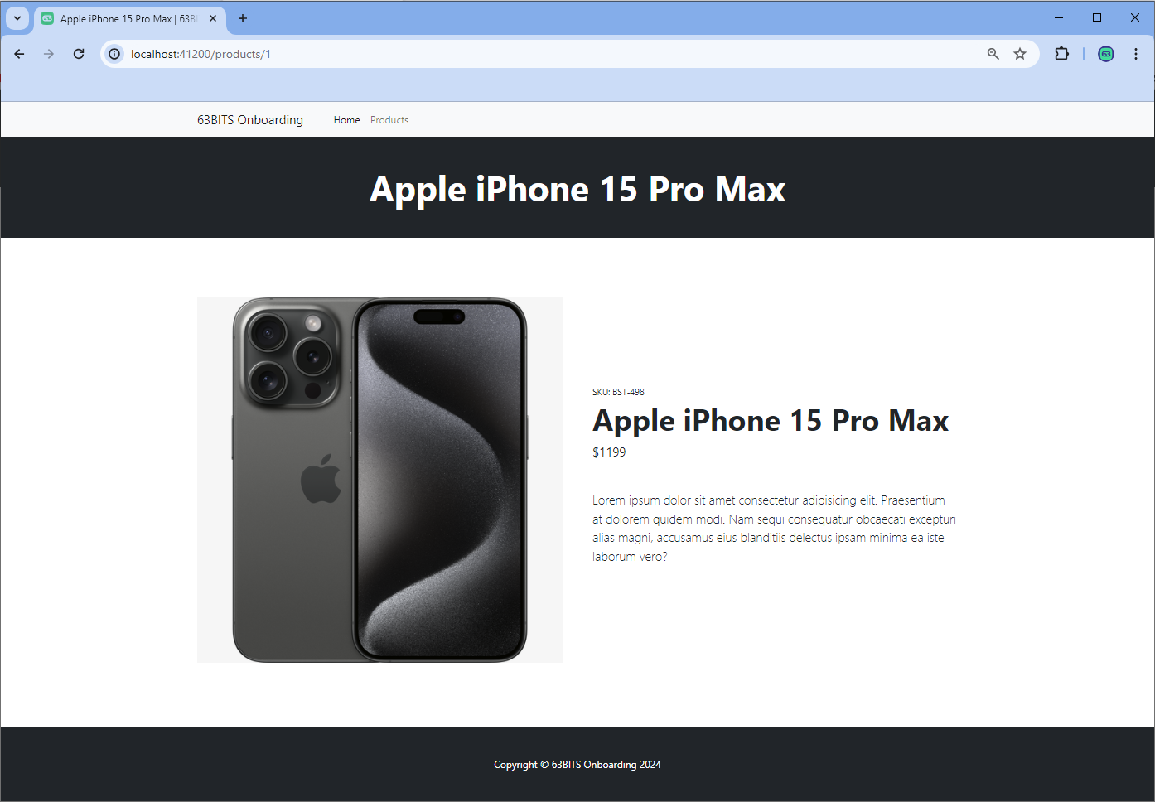

Link Pages
To complete our application layer, we need to link the Products Listing page to the Product Detail page.
Open ProductsWebsiteModel.cs and implement following changes:

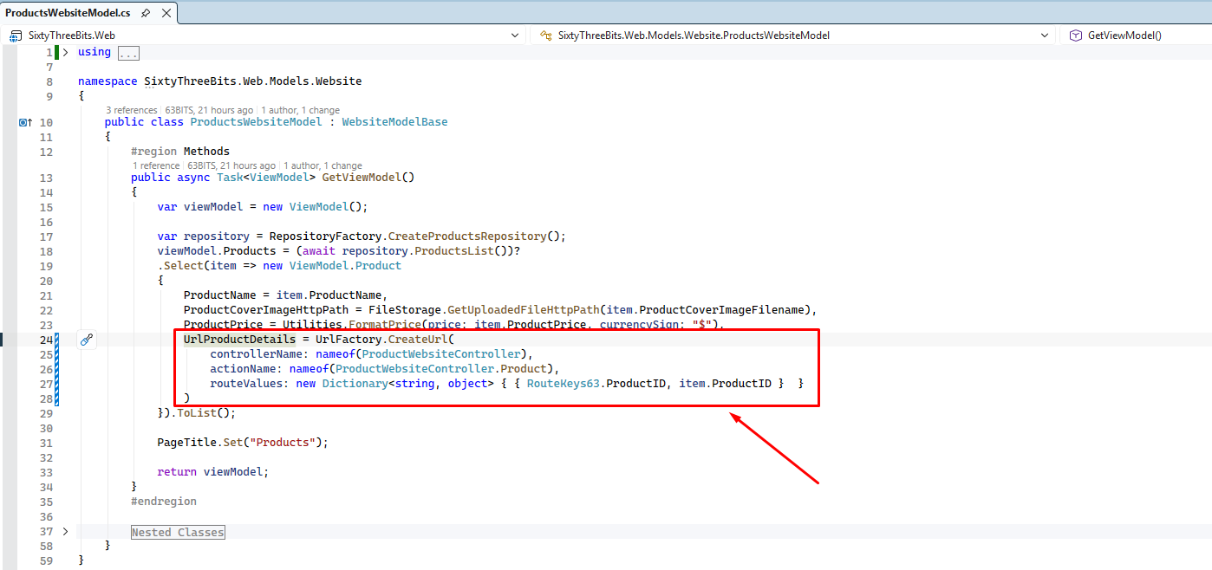

UrlFactory is an instance our custom-built class UrlFactory63, provided to the ProductsWebsiteModel by inheritance. It’s job is to create urls.
You provide
- controllerName – via nameof operator
- actionName – via nameof operator
- routeValues – via Dictionary<string, object> where
  - Key is RouteKeys63.ProductID (Hardcoding avoided again)
  - Value is item.ProductID
And it returns the url, to the Product Detail page according to ProductID.

Launch application again, navigate to the products page and click on „View Details“ button.
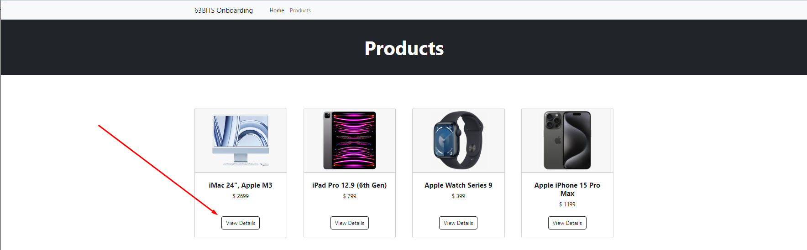

Upon click, product detail page will be loaded.
